**EXPERIMENT 5**

Q1- Write a HTML program to design a form which should allow to enter your enter your personal data using text field, password field, e-mail, lists, radio buttons, checkboxes, submit button.

Input:-

<html>

<head>

</head>

<body>

<form align="center">

<p>Name:<input type="text" placeholder="Enter Name"></p>

<p>Password:<input type="password" placeholder="Enter password"></p>

<p>e-mail:<input type="email" placeholder="Enter email"></p>

<p>Country:<select>

<option value="AF">Afghanistan</option>

<option value="AX">Åland Islands</option>

<option value="BF">Burkina Faso</option>

<option value="BI">Burundi</option>

<option value="KH">Cambodia</option>

</select></p>

<p>Gender:&nbsp;Male <input type=radio name="a"> Female <input type=radio name="a"></p>

<p>interests:&nbsp;qeww <input type=checkbox name="q"> vsdf <input type=checkbox name="v"></p>

<input type=submit>

</form>

</body>

</html>

Output:-

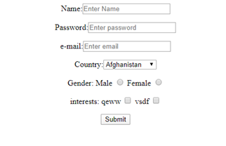

Q2- Write a HTML code to generate following output:-

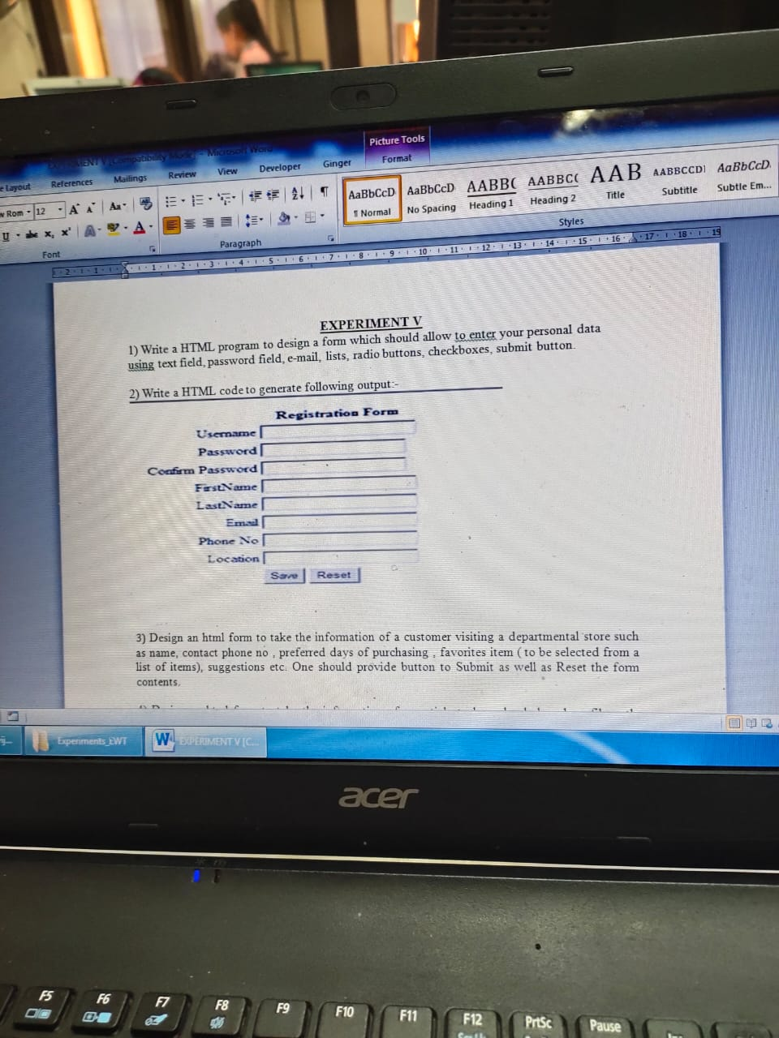

Input:-

<!doctype html>

<html>

<head>

<title>form2</title>

</head>

<body bgcolor=pink>

<form align="center">

<table cellspacing=4px align=center bgcolor=cream>

<thead>Registration Form</thead>

<tr><td>Username:</td><td><input type="text" ></td></tr>

<tr><td>Password:</td><td><input type="password"></td></tr>

<tr><td>Confirm Password:</td><td><input type="password"></td></tr>

<tr><td>First Name:</td><td><input type="text"></td></tr>

<tr><td>Last Name:</td><td><input type="text"></td></tr>

<tr><td>Phone No:</td><td><input type="number"></td></tr>

<tr><td>Email Id:</td><td><input type="email" ></td></tr>

<tr><td>Location:</td><td><input type="text"></td></tr>

<tr><td></td><td><input type=submit><input type="reset"></td></tr>

</table>

</form>

</body>

</html>

Output:-

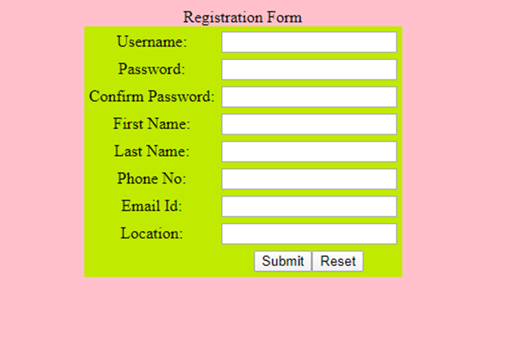

Q3- Design an HTML form to take the information of a customer visiting a departmental store such as name, contact phone no, preferred days of purchasing, favourites item(to be selected froma list of items), suggestions etc. One should provide button to submit as well as Reset the form contents.

Input:-

<!doctype html>

<html>

<head>

<title>departmental store</title>

</head>

<body bgcolor=pink>

<form align="center">

<table cellspacing=4px align=center bgcolor=cream>

<thead>Enter Details</thead>

<tr><td>Name:</td><td><input type="text"></td></tr>

<tr><td>Phone No:</td><td><input type="number"></td></tr>

<tr><td>Preferred days of purchasing:</td><td><input type="text"></td></tr>

<tr><td>Favorite items:</td><td><select>

<option value="AF">--select--</option>

<option value="AX">Chocolate</option>

<option value="BF">vegetables</option>

<option value="BI">butter</option>

<option value="KH">biscuits</option>

</select></td></tr>

<tr><td>Suggestions:</td><td><input type="text"></td></tr>

<tr><td></td><td><input type=submit><input type="reset"></td></tr>

</table>

</form>

</body>

</html>

Output:-

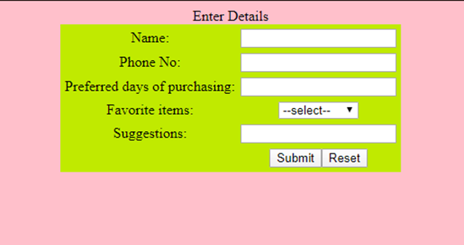

Q4- Design an HTML form to take the information of an article to be uploaded such as file path, author name, type(technical, literary, general), subject topic (to be selected from a list) etc. One should provide button to submit as well as Reset the form contents.

Input:-

<!doctype html>

<html>

<head>

<title>Article details</title>

</head>

<body bgcolor=pink>

<form align="center">

<table cellspacing=4px align=center bgcolor=cream>

<thead>Article Details</thead>

<tr><td>Upload file</td><td><input type="file" id="myfile" name="myfile"></td></tr>

<tr><td>Author Name:</td><td><input type="text"></td></tr>

<tr><td>type</td><td>technical <input type=radio name="a"> literary <input type=radio name="a">general <input type=radio name="c"></td>

<tr><td>Subject topic</td><td><select>

<option value="AF">--select--</option>

<option value="AX">AI</option>

<option value="BF">ML</option>

<option value="BI">DAta Science</option>

<option value="KH">Web Development</option>

</select></td></tr>

<tr><td>Phone No:</td><td><input type="number"></td></tr>

<tr><td></td><td><input type=submit><input type="reset"></td></tr>

</table>

</form>

</body>

</html>

Output:-

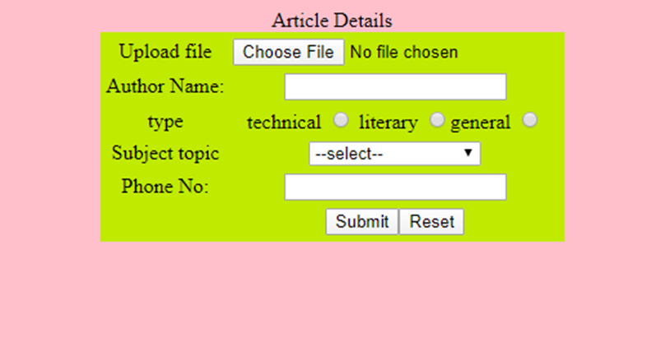

Q5- Write a HTML code to generate following output.

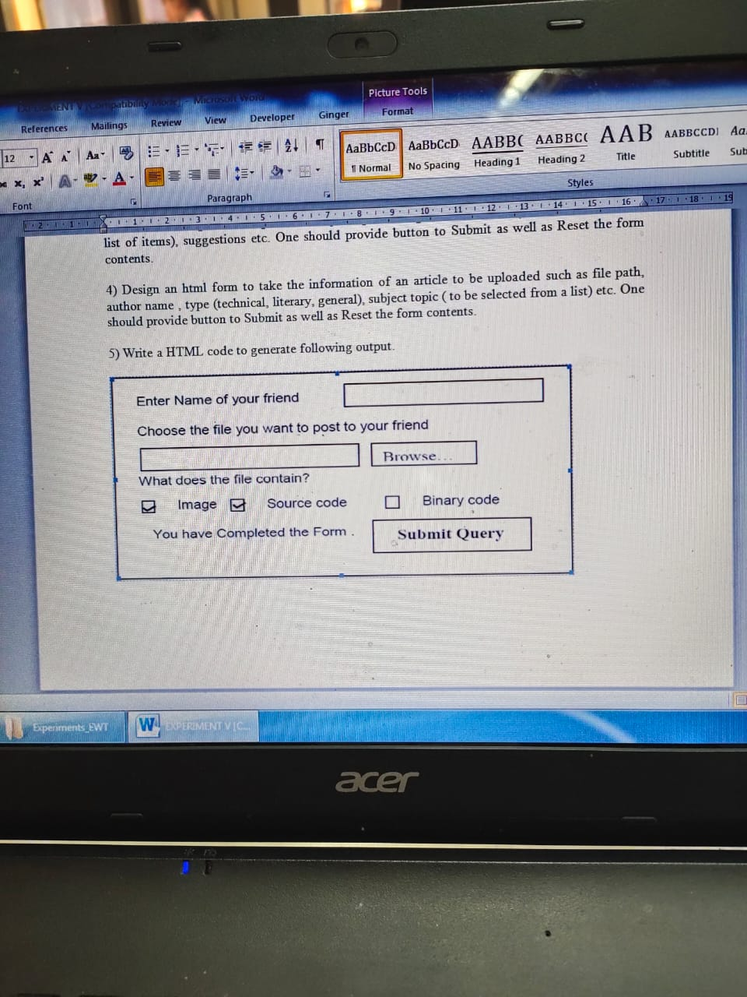

Input:-

<!doctype html>

<html>

<head>

<title> </title>

<style>

div{

border: 5px solid black;

}

</style>

</head>

<body>

<div>

<form align="center">

<p>Enter name of your friend:<input type="text"></p>

<p>Choose the file you want to post to your friend<br><input type="file" id="myfile" name="myfile" value="upload"></p>

<p>What does the file contain</p>

Image<input type=checkbox name="a"> Source Code <input type=checkbox name="a">BInary Code <input type=checkbox name="c">

<p>Enter name of your friend: <input type=submit value="submit query">

</form>

</div>

</body>

</html>

Output:-

